|  |  |
| --- | --- |
|  | Bangkok Branch |

**X3 ISO20022 System**

**Functional Specification**

**Version: 1.0**

**Issued: 03 Oct 2021**

**Status: Release**

Purpose of this document:

* To define system architecture and its modules
* To summarise function description by modules
* To summarise the workflow of the system
* To define major screen designs
* To define the report format

**Amendment History Block**

|  |  |  |  |
| --- | --- | --- | --- |
| **Version Number** | **Description of Change** | **Person Making Change** | **Date** |
| 1.0 | Initial Draft | Opat Liawsutee | 03 Oct 2021 |
|  |  |  |  |
|  |  |  |  |
|  |  |  |  |
|  |  |  |  |
|  |  |  |  |
|  |  |  |  |
|  |  |  |  |
|  |  |  |  |

**Distribution List**

|  |  |
| --- | --- |
| **Name** | **Title** |
|  |  |
|  |  |
|  |  |
|  |  |
|  |  |
|  |  |
|  |  |

**TABLE OF CONTENTS**

1 System Overview 4

1.1 System Objectives 4

1.2 System Flow 5

2 Screen Configurations 6

2.1 Create Screen Configurations 4

2.2 Import Screen Configurations 4

2.3 Export Screen Configurations 4

3 Manual Key In mx Message 6

3.1 Create Mx Message 4

4 Upload Mx Message csv 7

4.1 Csv File format 4

4.2 Upload csv file 4

5 Control and monitor 8

5.1 Delete Message 4

5.2 Approve Message 4

5.2 Release Message 4

6 Audit log 9

# System Overview

## System Objectives

NEW MANUAL ENTRY SYSTEM (X3). It is a system used for handling generated outgoing message in ISO20022 standard (MX) format. And many other business modules. From creating to sending messages to P4 BAHTNET ISO20022 System (P4). The main objectives of this system are

1. To handler outgoing message from creating or uploading from CSV file.
2. To display all outgoing message and show the status of them in MX outgoing.
3. To handler status of outgoing message: Complete, Approve and Release Process.
4. To make it easy to configure MX message type.
5. To handler outgoing message history in audit log.

## System Flow

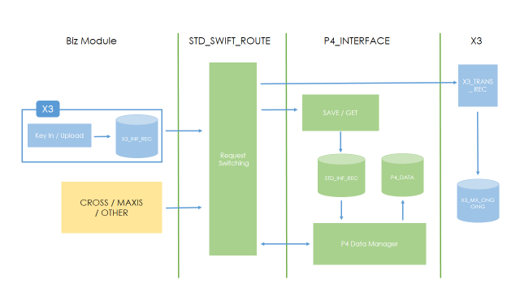

# Screen configurations Management

Screen configurations used for creating and managing ISO20022 Standard (MX) used in X3 systems.

## Create Sceen Configuration And Setting

Create Screen Configuration it is used to create Screen Configuration from ISO20022 Standard (MX). The steps are as follows.

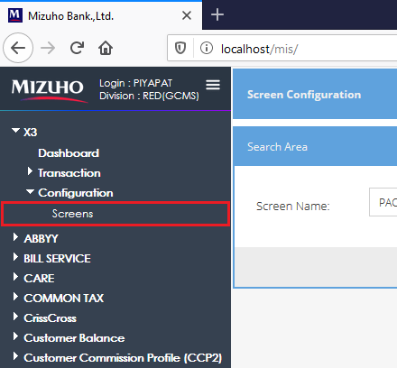

X3 > Configuration > Screens

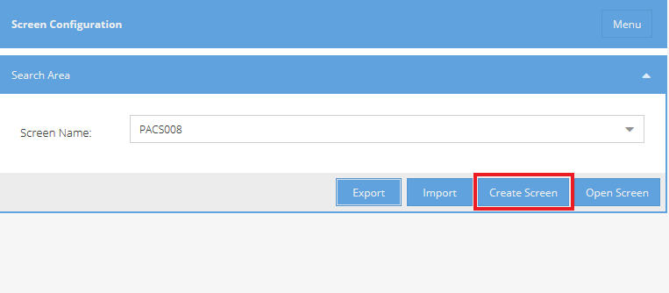

Click Create Screen

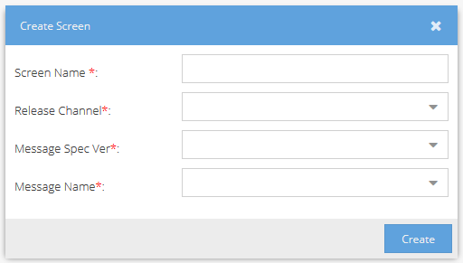

Input all field > Create

Screen Name: Just the name for Message Type at Manual Key In

Release Channel : ISO20022 Message release channel (BOT)

Message Spec Ver: Choose Message spec version.

Message Name : Choose ISO20022 Message Name

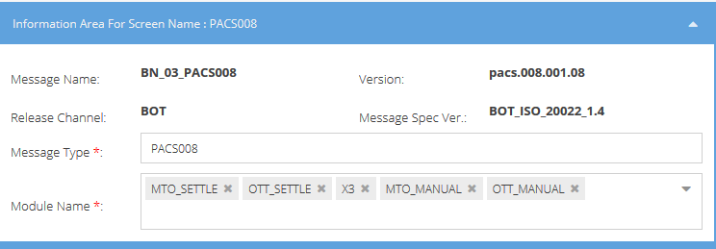

Input all field

Message Type : Define Message Type.

Module Name : Define Message Module

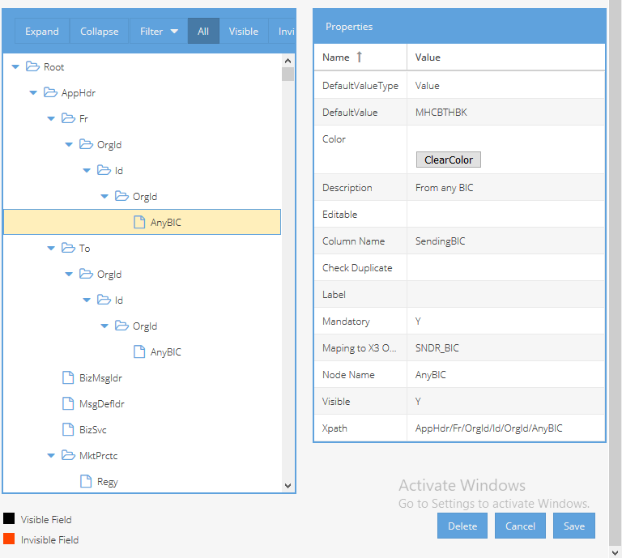

Setting Node Properties

Color : node color show at manual key in.

Description : message node description

Editable : config can editable at manual key in

Column Name : define naming in csv file format

Mandatory : set Mandatory field

Maping to X3 Outgoing : Mapfield to X3

Node Name : naming show in tree view

Visible : to show in tree view or not

Xpath : is the xpath of the node in the message

## Import Sceen Configuration

Add Screen Configuration via import file

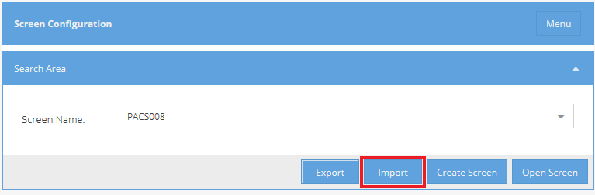

Click Import

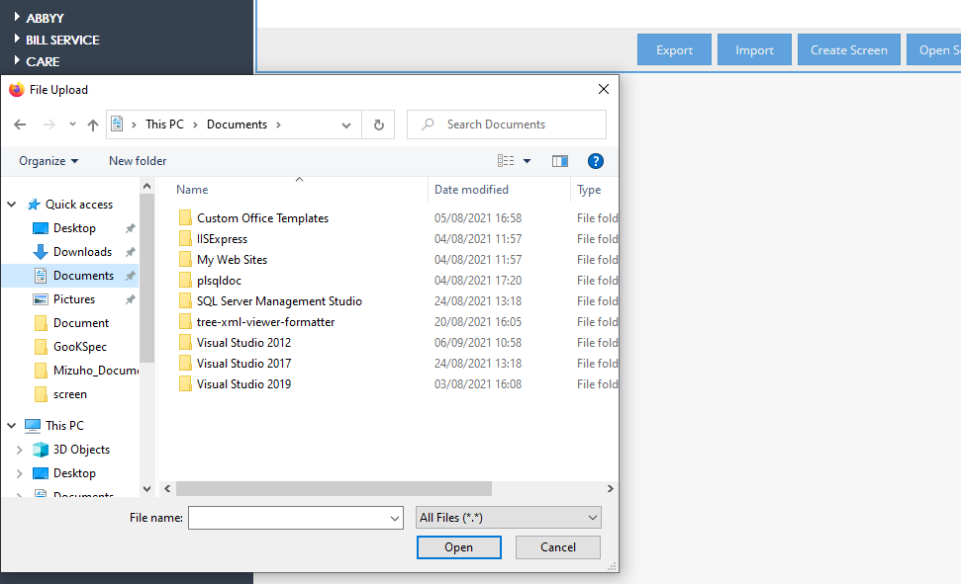

Select X3 Screen configuration file > Open

## Export Sceen Configuration

Export Screen Configuration

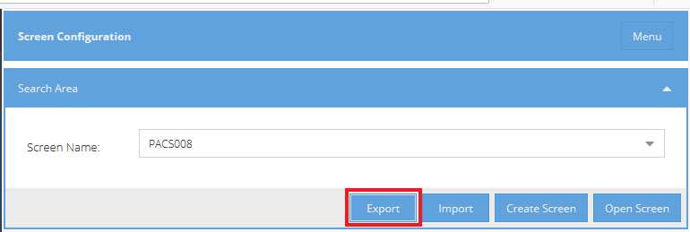

Select Screen Name > Export > Select Save File Location

# Manual Key In Management

Used for creating and outgoing ISO20022 standard (MX).

## Create Mx Message

Creating ISO20022 Standard (MX)

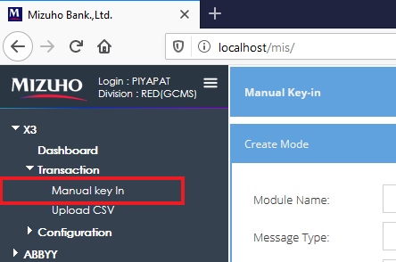

X3 > Transaction > Manual key in

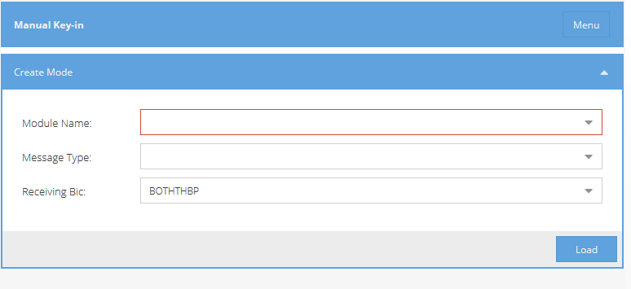

Input All Field > Load

Module Name: ISO20022 Standard (MX) System Module

Message Type: ISO20022 Standard (MX) Message Type

Receiving Bic: Select Receiving Business

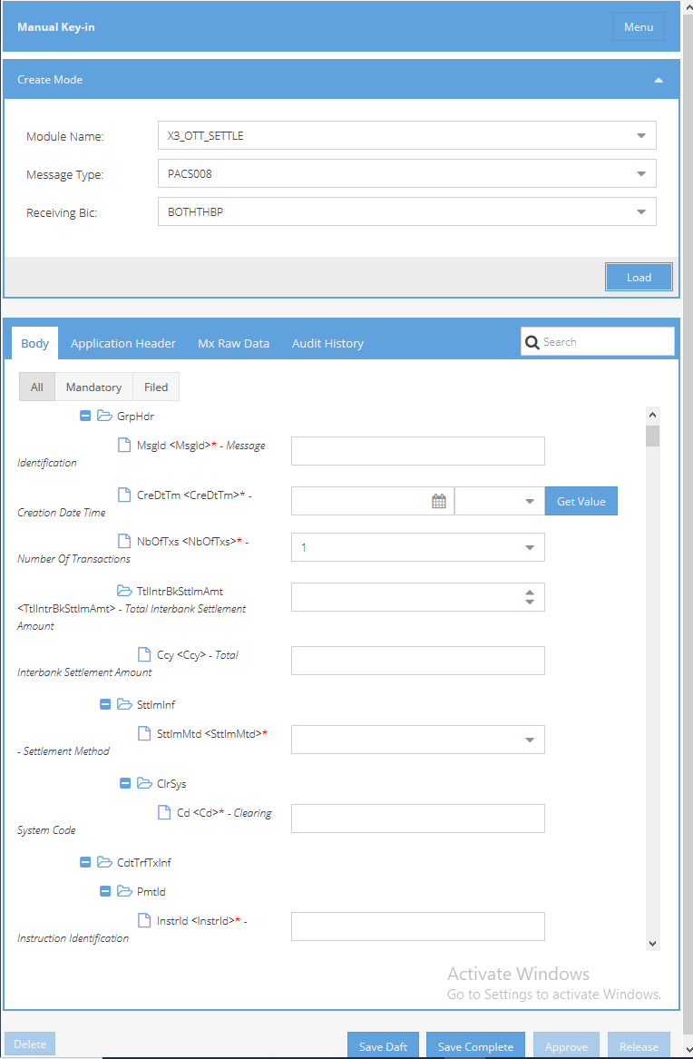

Input All Require Mandatory field > Save Draft or Save Complete

# Upload Mx Message csv

Used for uploading ISO20022 Message from CSV format file.

Upload csv file

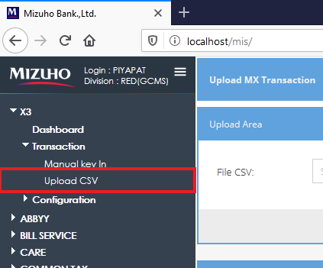

X3 > Transaction > Upload CSV

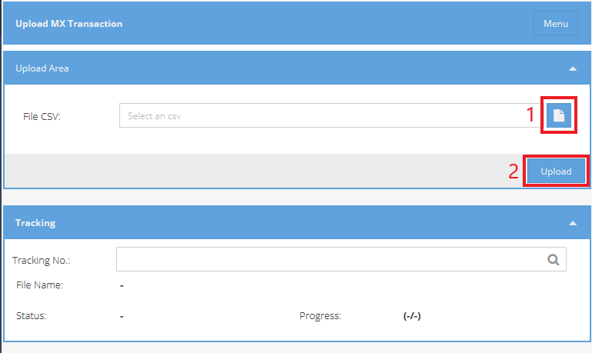

Step 1 : select csv file to upload

Step 2 : Press “Upload” to start uploading csv file.

Tracking No : Used for checking whether the upload was successful or not.

# Control and monitor

Used to view and manage all ISO2002 Standard (MX) Messages.

## Search MX Outgoing Transaction

MX Outgoing Transaction Search criteria

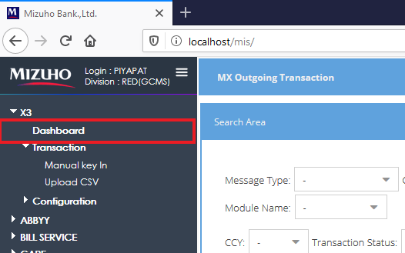

X3 > Dashboard

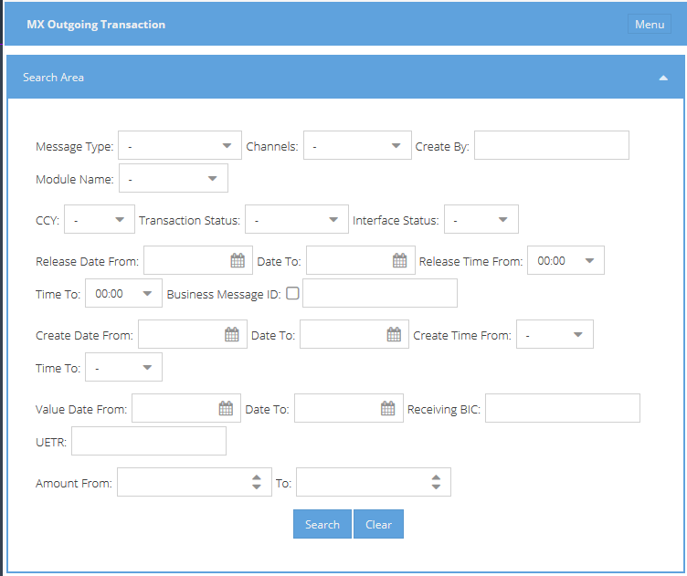

Input Criteria field

Message Type: ISO20022 Standard (MX) Message Type

Channels : channel of outgoing ISO20022 Standard (MX)

Create By : Create User.

Module Name : ISO20022 Standard (MX) System Module

CCY : Outgoing currency

Transaction Status : Status of Outgoing Message

Release Date : Release Date of Outgoing Message

Release Time : Release Time of Outgoing Message

Create Date : Create Date of Outgoing Message

Create Time : Create Time of Outgoing Message

Value Date : Value Date of Outgoing Message

Receiving Bic : Receiving Business

UETR : Unique number

Amount : Amount balance of Outgoing Message

5.2 Delete MX Outgoing Transaction

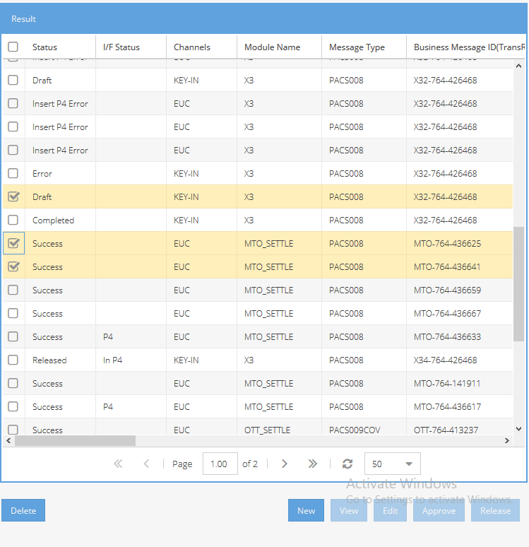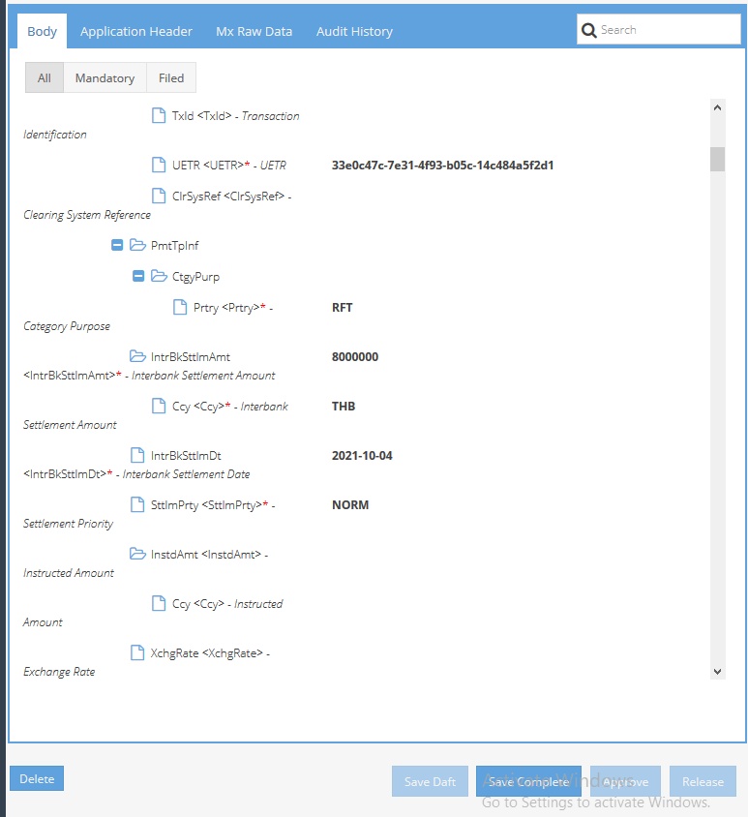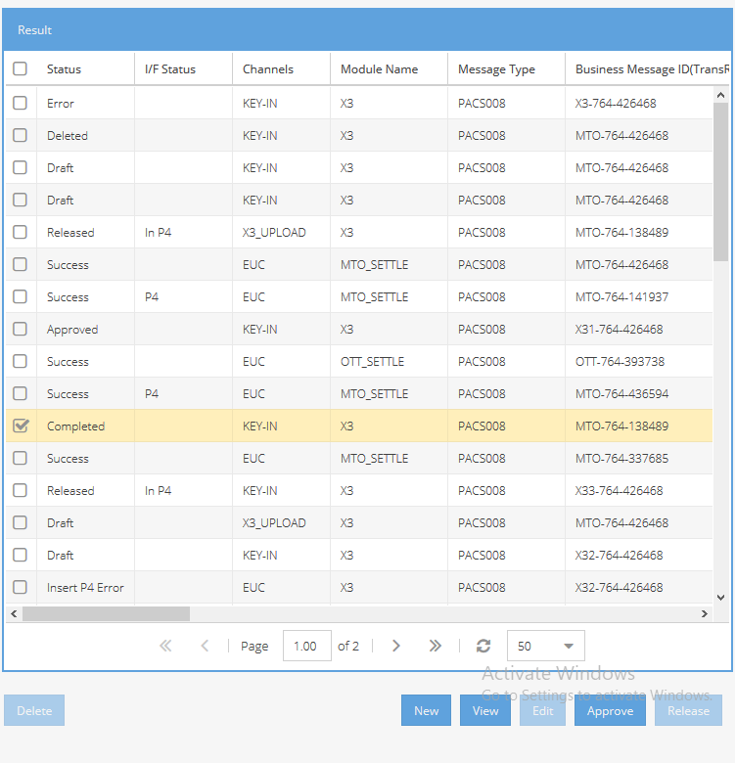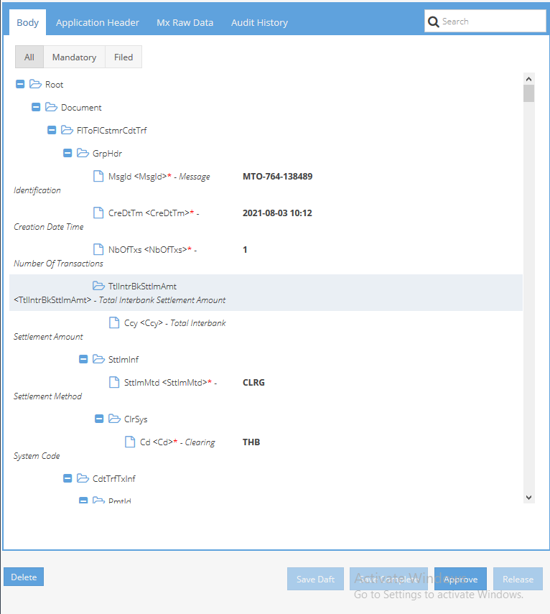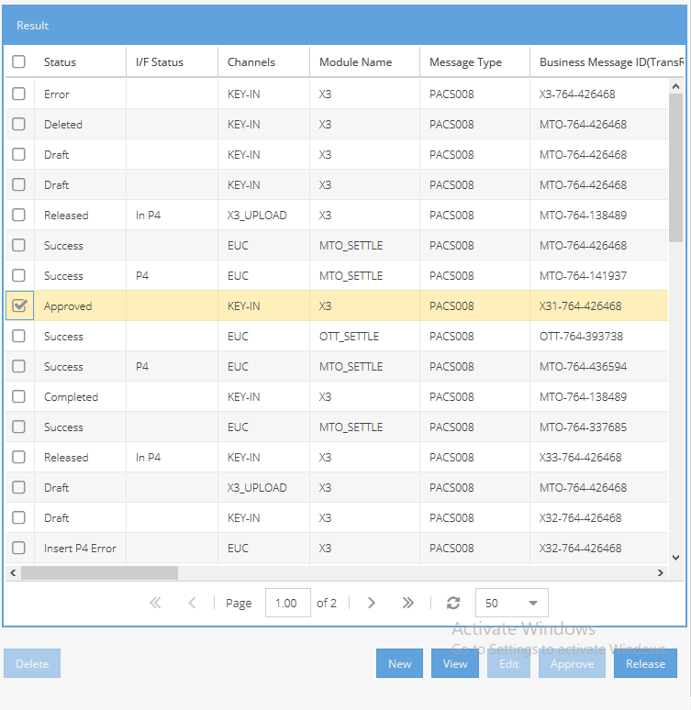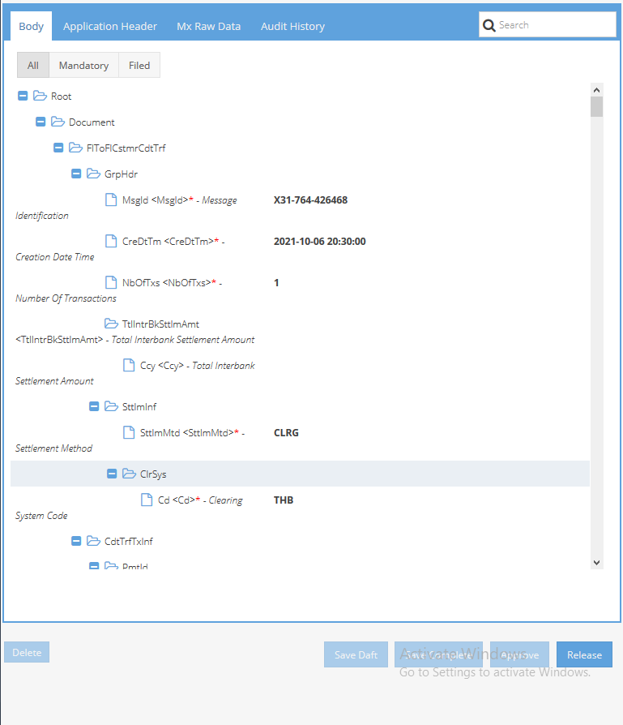

# Audit Log

Show status and correction of ISO20022 Standard (MX) Transaction.

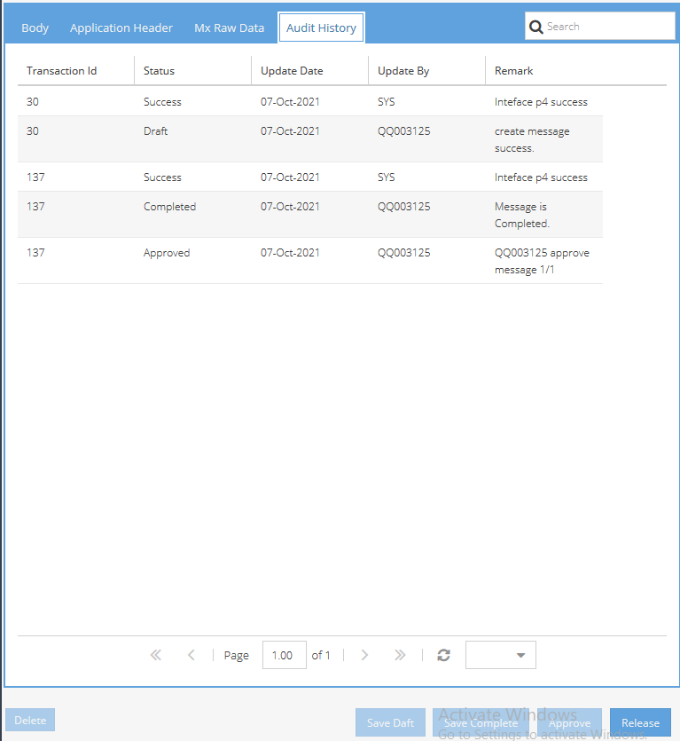

X3 > Dashboard > Select Message > View > Audit History